AP U.S. History: Unit 1.1
Chapters 1 – 4 (American Pageant & AMSCO)

Reading Assignments:
Chapter 1:
8/16 – AP pgs 4-15

8/18 – AP pgs 16-24

8/19 – AMSCO Introduction & pgs 1-13
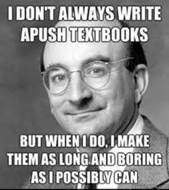
Chapter 2:
8/23 – AP 25-32

8/25 – AP 32-42

8/26 – AMSCO pgs 23-35

Chapter 3:
8/30 – AP pgs 43–52

9/1 – AP pgs 52–63

9/2 – AMSCO pgs 42-53

Chapter 4:
9/6 – AP pgs 66-76

9/8 – AP pgs 76-83

9/9 – AMSCO – pgs 60-69

REVIEW – Tuesday, 9/13
Exam – Thursday, 9/15

Things to remember!!
- Take written notes while you are writing!!
  - YOU CAN USE THESE NOTES ON YOUR READING QUIZ!!
  - YES, YOU WILL HAVE DAILY READING QUIZZES AS SOON AS CLASS BEGINS.

- There are 42 chapters in this book. I have done the math and we MUST maintain a chapter a week to meet the final goal.

- If you are absent – Class and your reading assignments still continue as scheduled. See me for your makeup quiz when you return.

- YOU MUST READ TO PASS THIS CLASS!! Failure to do so will result in parent contact, counselor/principal contact and further action as needed.

