Chapter 5
Immigration & Urbanization

Wednesday, 9/7
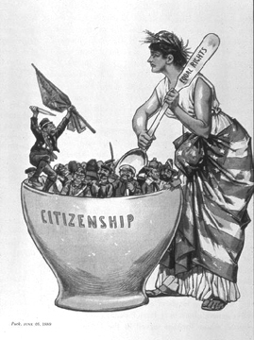
- 5.1 – The New Immigrants

Friday, 9/9
- 5.2 – Cities Expand & Change
- 5.1 Review Handout due!!

Monday, 9/12
- City of Lights Video
- 5.2 Review Handout due!!

Wednesday, 9/14
- 5.3 – Social & Cultural Trends
REVIEW: Friday, 9/16
TEST: Monday, 9/19
- 5.3 handout due!!

