AP Psychology
“Updated” Unit 1 Schedule

Tuesday, 9/6
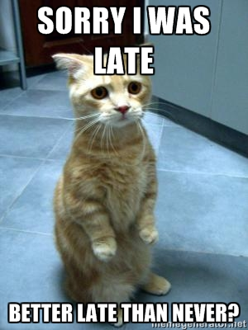
- Module 3 reading quiz
- Review Module 2 & 3

Wednesday, 9/8
- Nature vs Nurture essay due!
- Review Unit One

Friday, 9/10
- Unit 1 Quiz

