AP Psych Unit 3 Schedule

Week 1
**Modules 9 & 10 Quizzes are completed!!
Tuesday, 10/18
*M9&10 PPT & Discussion

Thursday, 10/20
*M11 Discussion & Activity

Friday, 10/21
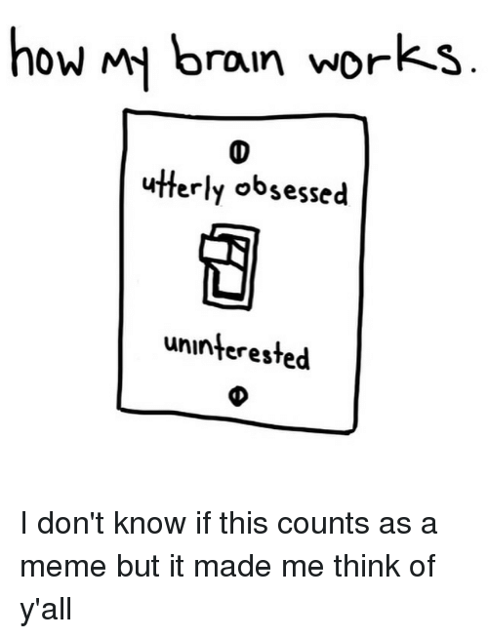
*5S2A5 Presentation – Ch 4 __________________________
*M11 Quiz

Week 2
Tuesday, 10/25
*M12& 13 PPT & Discussion
*M12&13 Quiz

Thursday, 10/27
*Unit 2 Activity

Friday, 10/28
*5S2A5 Presentation – Ch 5 _____________________________
UNIT 3 Exam – Tuesday, 11/8

Week 3
Tuesday, 11/1
*M14&15 Quiz
*M14&15 Discussion & Activity

Thursday, 11/3
*REVIEW UNIT 3
Friday, 11/4
*5S2A5 Presentation – Ch 6 - ____________________

